SCOTTISH CAPITAL
INVESTMENT MANUAL

NHSScotland
Commissioning Process

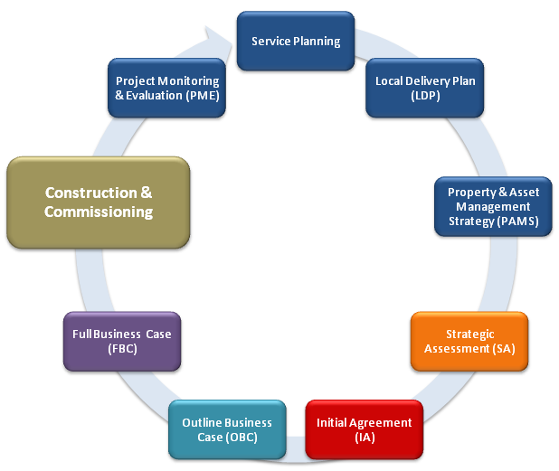

Contents
1 Overview 1
2 How do we start the commissioning process ? 5
3 What are the key elements of the commissioning process ? 15
4 List the various typical tasks in a commissioning programme? 18

Appendix A – Sample Commissioning Risk Register 53
Appendix B – Sample Migration Plan 55
Appendix C – Sample extract from a Technical Commissioning Plan 56
Appendix D – Sample extract from an Equipping Responsibility Matrix (ERM) 57
Appendix E – Schedule of Activities 59

Figure 1: Health & Social Care facilities commissioning diagram 1
Figure 2: Schedule of Activities 3
Figure 3: Key Tasks Checklist 4
Figure 4: Typical Public Procurement Management Structure 5
Figure 5: Working Groups Typical Functions Diagram 10
Figure 6: Checklist for Creating Standard Operating Procedures (SOPs) 21
Figure 7: Typical Equipping Strategy Diagram 27
Figure 8: Typical Equipment Group definitions 29
Figure 9: Typical TADs Considerations Diagram 42
Figure 10: Typical Art /Greenspace Considerations Diagram 43

Overview
The purpose of this guide is to provide a best practice overview of the technical and operational activities needing to be completed to ensure the smooth transition of services into a fully functioning new facility. Although this is intended for projects to be considered by the Capital Investment Group (CIG), it is anticipated that Boards/ Clients will use these best practice principles on all investment projects.

Introduction
The importance of the commissioning process cannot be under-estimated, as failure to adequately consider this process is likely to cause increases to project costs and failure to deliver agreed service benefits and project outcomes.
Figure 1 establishes how the commissioning process should be organised, the key tasks to be addressed, and provides advice on:
- Technical Commissioning and Operational Commissioning.
- BIM and Soft Landings: the best practice principles of BIM and Government Soft Landings must be embedded at every stage to deliver a high quality, safe, and efficient care facility.
Figure 1: Health & Social Care facilities commissioning diagram

The commissioning process should be treated as a distinct sub-project, but fully integrated into the overall project to enable a smooth transition to the new working arrangements and realisation of the anticipated benefits.
Inputs will range from establishing teams and processes e.g. brief for the Building Information Management (BIM) technical data format, to coordination and PR communication of a comprehensive migration plan.
Figure 2, overleaf (and repeated as A3 in Appendix E), provides a high level summary of the main activities expected throughout the planning and delivery of the commissioning process, and how it overlaps with the business case process and soft landings best practice.
All resources necessary to fulfil the requirements of the commissioning process need to be identified within Commissioning Master Plan developed at Outline Business Case stage. This will include setting up a commissioning team which may include senior, departmental, estate, and facility managers; plus other technical support and service users. Appropriate administration support will be crucial to coordinate the flow of information within these dynamic groups in a timely manner.
Projects procured through PPP / private finance, AND contain facility management responsibilities within the contract, will need to define within the Commissioning Master Plan how shared (NHS / private sector) and individual responsibilities and risk ownership for technical and operational commissioning are to be allocated. The public sector client will, however, still need to be assured that all activities are carried out appropriately to ensure delivery of a high quality, safe and efficient care facility, irrespective of the chosen procurement method.
A checklist of key commissioning tasks is provided in Figure 3. Reference should also be made to the relevant sections in this guide, where more detail can be found.

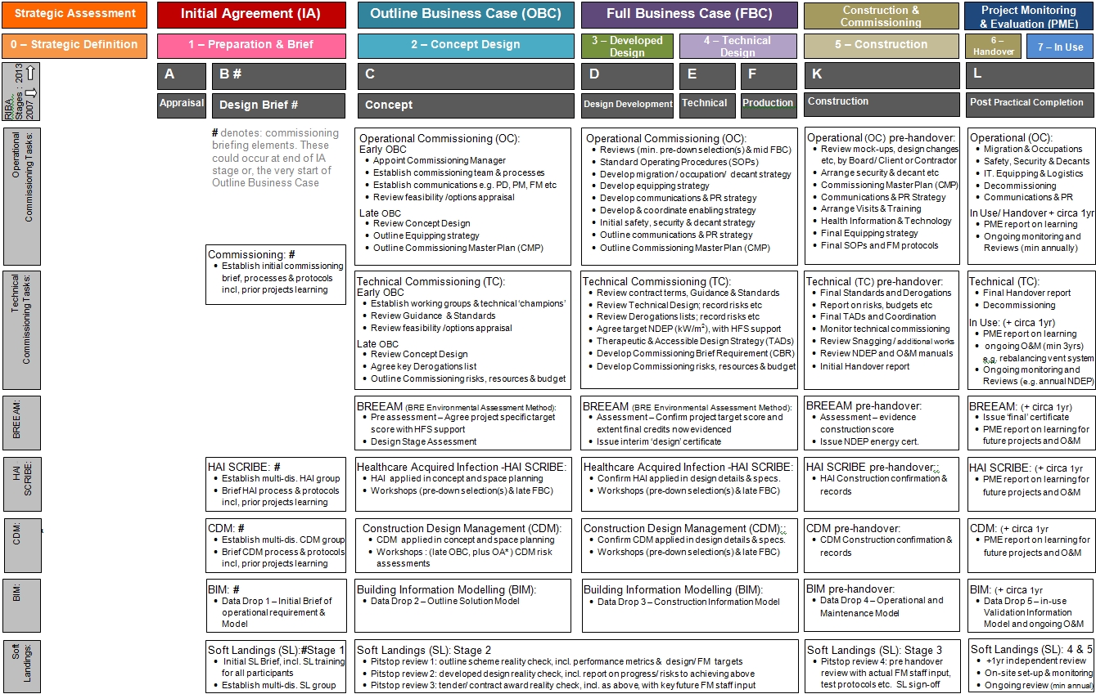
Figure 2: Schedule of Activities
Summary of Key Tasks | Relevant Section | Owner  Initials | Date Action Complete
Section 2 – Project Initiation
Confirm and publish the management structure | 2.1
Appoint a commissioning manager | 2.2 - 2.3
Appoint a commissioning team | 2.4 - 2.5
Appoint a soft landings champion | 2.6 - 2.8
Establish smaller working groups | 2.9
Establish/maintain link with the client project team | 2.10
Establish/maintain link with the designer(s) ; contractor(s) and suppliers | 2.11
Section 3 – Planning For Commissioning
Establish/maintain commissioning master plan (CMP) | 3.1
Establish whether enabling schemes are required | 3.3
Establish/maintain project risk register (commissioning elements) | 3.4
Establish/maintain the commissioning requirements brief (CRB) | 3.5
Section 4 – The Commissioning Programme
Establish operational procedures | 4.1
Establish communications strategy | 4.2 & 4.24
Establish / maintain resource & budget plan | 4.3
Review/ Agree OBC and FBC proposals | 4.4 - 4.5
Establish/maintain the migration plan | 4.6 - 4.8
Establish a strategy for equipping including selection, delivery, storage, removal etc. | 4.9 – 4.15
Review/agree site visits and training plan | 4.16
Review/agree technical commissioning plan | 4.17
Review/agree therapeutic environment plan | 4.18
Review/agree wayfinding / signage plan | 4.19
Review/agree snagging plan | 4.20
Arrange post-handover building security | 4.21
Decommission redundant facility | 4.22 - 4.23
Review/agree operational handover plan | 4.25
Arrange official opening ceremony | 4.26
Figure 3: Key Tasks Checklist

How do we start the commissioning process?
Establish commissioning structure;
establish leads & communication lines;
establish initial brief, programme & budgets.
How do we start the commissioning process?
HOW
Response
Question

Organising the Commissioning Process
It is essential that an appropriate commissioning structure is in place to meet the requirements of the commissioning function, with clear lines of accountability and reporting established. The organisation of the commissioning process should flow directly from the overall project management structure, for which a Senior Responsible Officer and Project Director will have been identified. .
A typical organisational chart used in the commissioning process, which identifies hierarchical relationships, is shown in Figure 4 below.
Client / Investment
Decision Maker
(e.g. SRO in NHS Board)

Figure 4: Typical Public Procurement Management Structure

Appointment of the Commissioning Manager
The Commissioning Manager will be identified within the Commissioning Master Plan at OBC stage. This will include an outline of their role and responsibilities, an indication of their competency to carry out this role, and any continuity plans in place for this important role. This is to be fully defined and confirmed at FBC stage.
The Commissioning Manager/ Team should be appointed as early as practicable during the investment planning process to that the commissioning costs, resources and associated risks are understood and allocated appropriately.
The Commissioning Manager could be:

- An existing lead service manager
- A new Commissioning Manager appointed by and working for the Project Director.
- A new Commissioning Manager working for the overall programme development manager (with the Project Director responsible for the construction project).
- The existing Project Manager (temporary role)
Dependent upon the complexity of the project, the Commissioning Manager could be a lead service manager in smaller projects. Ideally the Project Manager and Commissioning Manager should be two distinct roles to ensure there is no conflict of interest/ workload, with the Commissioning Manager reporting separately to the Project Director.
The Commissioning Manager could be a senior manager within NHSScotland or an external appointment. They could be an existing employee, specifically recruited, or a secondee for the period of the commissioning process. What is essential is that the commissioning manager holds the required skill sets and experience that is required for this specific and complex task.
For very large/ complex projects/ programme it may be necessary to appoint a Senior Commissioning Project Manager to co-ordinate the activities of a team of Commissioning Managers on behalf of the Project Director.
The size of the project may require the Commissioning Manager to have a number of commissioning support teams. It is important that appropriate resource/ workforce planning is undertaken to address the needs of staff and the different stages in the procurement.
Appropriate administrative support and resources will be essential for the Commissioning Manager to ensure timely flow of information between the various stakeholders and organisations.

Duties of the Commissioning Manager
The duties of the Commissioning Manager should encompass:
- Chairing and managing the business of the commissioning team and overseeing any supporting working groups set up to undertake detailed work, co-ordinating input where appropriate, particularly in relation to cross-group issues.
- Establishing the key programme for bringing the facility into use - the Commissioning Master Plan (CMP) - and agreeing this with senior management, plus internal/ external stakeholders.
- Maintaining and developing the CMP as the project progresses.
- Establishing commissioning needs and processes - the commissioning requirements brief (CRB) - with the senior management, plus internal/ external stakeholders.
- As above, establishing decommissioning need where required. Refer to www.hfs.scot.nhs.uk for de-commissioning guidance.
- Maintaining and developing the CRB as the project progresses.
- Arranging review of Outline then Full Business Case proposals and report on commissioning compliance (CRB) and risks.
- Establishing and maintaining a commissioning risk register.
- Managing the commissioning and decommissioning budget.
- Establishing and maintaining the communications strategy for a variety of internal and external parties, including PR.
- Managing the effective involvement and support of the key stakeholders in the commissioning process – working groups.
- Liaising closely with the Project Manager on the progress of the construction project, particularly if commissioned in phases.
- Liaising with operational management on testing working and operational procedures, and identify risks for functions to be carried out within the facility.
- Ensuring that the strategy for equipment is appropriately defined at the Outline then Full Business Case stages; with procurement routes, budgets and programmes for equipment, surveys, storage, installation and waste removal in place.
- Reporting progress / risks to the Project Director against the Outline and Full Business Case assumptions.
- Liaising with the Project Manager for the briefing, delivery and storage requirements of equipment which will need to be put in place by the designers / contractor as part of the project.
- Liaising with the Project Manager to coordinate the briefing and delivery requirements, etc, of Arts, Wayfinding and Greenspace commissioning into an integrated therapeutic environment (including Therapeutic & Access Design Strategy (TADs)).
- Providing regular reports on progress against the Commissioning Master Plan (CMP), and on staffing and revenue projections, to the Project Director and key stakeholders.
- Organising / managing the transfer of services and patients into the new facility – the migration plan.
- Managing the transition of the facility over to operational management including establishing training, site visits, snagging and handover needs, agreeing processes and liaising with contractor and key stakeholders.
- Collecting and reviewing information relevant to the future post project evaluation.

Commissioning Team
The commissioning team should operate under the direction of the Commissioning Manager. Its function is to support bringing the building into use and the efficient delivery of the project’s business objectives.
The commissioning team should be drawn from staff and users of the facility, including representatives from the range of support staff required for the facility.
To ensure consistency between implementation of the construction project and commissioning, clear actions and reporting mechanisms across teams are required. The Project Director and Project Manager should be members of the commissioning team.
The resources required for commissioning need to be planned for at Outline Business Case stage and then confirmed in the Full Business Case, as the overall briefing, programme and cost must include commissioning.

Working Groups
It is recommended for projects with a large number of different operational user groups, that smaller working groups are established. Figure 5 below outlines typical functions of these groups.
Working groups will be chaired and managed by the Commissioning Manager, or commissioning team deputy. The frequency of meetings should reflect the number/ complexity of issues being managed.
Membership of working groups should utilise service users who are also involved in the design development process. It should also consider the need for specialist or technical champions on subjects such as Soft Landings, BIM, Sustainability, Design, Health Promotion, Fire Safety, Infection Control (HAI), Therapeutic & Access Design Strategy (TADS), etc. to include patients/ users, carers, access panellists, key staff, art and greenspace representatives.
Each member of the working group has a responsibility to liaise with colleagues/ representatives to ensure relevant commissioning information is available timeously, and disseminated appropriately.
Plans drawn up by the working groups must be formally accepted in writing by the designated operational service manager. Thereafter any changes to the plans must be formally agreed by the Commissioning Manager.
All documentation shall be dated and supported by action notes arising from each meeting of the working group.
Figure 5: Working Groups Typical Functions Diagram
Identify, review and sign-off on
elements in the Commissioning Requirements Brief (CRB)

Identify, review and sign-off on Operational Procedures
Identify, review and sign-off on occupation programme for Migration Plan
Identify, review and sign-off on specialist /.tech-nical issues, e.g. BIM, HAI, sustainability
Identify, review and sign-off on TADS plan requirements, e.g. Art, Access & Greenspace

Identify, review and sign-off on Equipping requirements
Identify
operational and technical Training requirements
Report to Commissioning Manager on Risks & CMP, i.e. progress on agreed targets
Working Group
Typical
Functions

Links with the Project Team
Strong relationships and reporting mechanisms are essential between members of the client commissioning team and the client project team on the establishment of and regular review of the project brief, design and construction against the following:
- Commissioning Requirements Brief (CRB)
- Commissioning Master Plan (CMP)
- Migration Plan
- Risk Register
- Communication Strategy
- Ongoing work of the Working Groups.
The Commissioning Manger will report regularly on the above and any budget / resource implications to the Project Director, who will in turn report to the Senior Responsible Officer (SRO). This is necessary as senior management are integral to the governance of the project and need to be made aware of emerging difficulties or changes to the agreed programme of implementation.

Links with the Contractor, Designers and Suppliers
The first point of contact with the contractor, designers and suppliers should be through the Project Director, or where agreed the Project Manager. The Commissioning Manager or a member of the commissioning team should be present at key progress meetings throughout, and particularly during the later stages of the project. This will ensure good working relationships and facilitate coordination of the project, thus reducing potential problems arising in-use.
The Commissioning Manager should develop good relations with the contractor, designers and suppliers to ensure they understand the Commissioning Requirements Brief (CRB), and coordinate the delivery of effective, practical solutions to identified in-use issues. A typical example might be equipping coordination where imaging rooms are designed to accommodate not yet procured NHS specialist machines.
It is essential that any changes required by the Commissioning Manager / team follow an approved formal change control process.

Soft Landings and BIM
Soft Landings (GSL) is a process designed to assist the construction industry and its clients to deliver better, more operationally effective buildings. It involves those that use and maintain the facility at the outset and in the design, requires extended aftercare, and mandates feedback (BSRIA, BG54/2014 - The Soft Landings Framework).
Building Information Management (BIM) is a strategy for asset management, information exchange and collaboration using current digital media. PAS 1192:2 defines BIM level 2 maturity and should be employed to improve quality and efficiency of the facility. The success of BIM is the client’s development of an appropriate BIM Strategy at IA, supplemented by the Employer’s Information Requirements (EIRs) and the Asset Information Requirements (AIR) early in OBC stage.
NHSScotland has mandated the use of both the Soft Landings and BIM level 2 as an integrated approach for new-build projects over £3m construction value from April 2017. However, they are considered as ‘best practice’ for the procurement, design and commissioning of ALL care facilities. HFS has developed NHSScotland BIM Standards, see www.hfs.scot.nhs.uk for templates etc.

Appointment of Soft Landings and BIM Champion(s)
The Project Director will identify Soft Landings and BIM Champion(s) who have the responsibility to ensure that the Soft Landings and BIM Strategy(s) are developed / delivered at each stage of the project. Initially reporting to PD/PM until the Commissioning Manager is appointed, they will brief, report on and monitor progress to ensure that their strategy is embedded into the entire procurement, design, commissioning and operational use of the facility.
The appropriate Champion(s) will have technical aptitude plus an interest in the in-use performance of the building, and should be in-place / available to the team for the full duration of the project. Examples include: project manager, commissioning manager, client technical / support representative, or an external design consultant.
The PD /PM or Commissioning Manager will ensure that the Soft Landings and BIM Champions are part of the routine management of the project and are properly resourced.

Soft Landings and BIM processes
The Soft Landings (GSL) process raises awareness / embeds in-use performance at early stages of briefing. It then assists the management of expectations through OBC feasibility to FBC design, and later into construction and operational use; with particular attention to the technical commissioning and detail in the weeks immediately before and after handover. Extended aftercare, with monitoring, performance reviews and feedback, all help occupants to make better use of their buildings while clients, designers, builders and managers gain a better understanding of good practice for future projects.
BIM describes a series of client decision gateways that have data exchanges / ‘drops’ aligned with them that facilitate the development of a robust interrelated shared electronic data environment. These data drops align with key stages in the Business Case process:
Further information on Soft Landings & BIM can be found at:
- DATA DROP 1 Late IA / or very start of OBC
- DATA DROP 2 Early OBC
- DATA DROP 3 Late OBC
- DATA DROP 4 FBC
- DATA DROP 5 Handover and Close Out
The alignment of the BIM data drops and the Soft Landings process with the project work stages and gateways will provide a fully co-ordinated and streamlined approach to brief inputs and conclusion, design sign-offs, user interfaces, handover, commissioning and facility operation; together with future asset reporting requirements.
Soft Landings procedures are designed to augment standard professional scopes of service, not to replace them. They are tailored to run alongside standard procurement routes to create the most appropriate service to suit the project concerned.
The scope of key Soft Landing (GSL) requirements across the critical planning stages are:
- Inception and briefing: appoint BIM / GSL champions, set brief (e.g. EIR), and manage expectations for performance in-use. Plus clarify the GSL duties / procedures of client, FM, design and building team members.
- Design development: Set up Common Data Environment (CDE) for drawings, specification and construction. Review, report on and monitor the likely performance against the brief / expectations and achieving specific in-use outcomes.
- Pre-handover: Set out and implement programme to involve / train client, FM, design building team, incl. specialists e.g. controls, in commissioning to strengthen the operational readiness of the building.
- Initial aftercare: Facility based representative or team to pass on FM knowledge, optimise FM, and rapidly respond to queries / problems on site during the facility /users’ settling-in period.
- Aftercare in years 1 to 3 after handover: Quarterly reports with periodic monitoring and review of building performance.
Further information on Soft Landings & BIM can be found at:
- www.softlandings.org.uk
- www.bsria.co.uk
- www.bimtaskgroup.org/gsl/
- www.bimtaskgroup.org/pas11922-overview
- www.hfs.scot.nhs.uk

What are the key elements of the commissioning process ?
Set commissioning requirements brief (CRB);
prepare commissioning master plan (CMP);
establish procurement methods; identify any enabling schemes; provide risk register.
What are the key elements of the commissioning process?
WHAT
Response
Question

Organising the Commissioning Process
The Commissioning Manager; drawing on the advice of the commissioning team and the working groups, will establish the Commissioning Requirements Brief (CRB) as a key document early in the project’s inception. As the project develops it will be developed, maintained and signed-off at key stages by the Commissioning Manager for issue to internal and external stakeholders. It is an integral part of the Employer’s Information Requirements (EIRs) and Asset Information Requirements (AIR) under BIM.
A typical project Commissioning Requirement Brief (CRB) includes:
- Project overview.
- Soft Landings and BIM strategy.
- Technical commissioning & aftercare.
- Equipping strategy.
- User guides and templates.
- Training and site visits protocols.
- Handover and snagging protocols.
- Commissioning Master Plan (CMP) & supporting programmes.
- Communications strategy.
- Risk Register (restricted).
- Resources & budgets (restricted).

The Commissioning Requirements Brief (CRB) needs to be outlined at Outline Business Case (OBC) stage to enable incorporation into contractors’, designers’ and suppliers’ briefs. Following initial development of the design / solution the detailed CRB is to be confirmed in the Full Business Case (FBC).

The Commissioning Master Plan (CMP)
The Commissioning Master Plan is to be outlined at Outline Business Case stage with firm details confirmed at Full Business Case stage.
The Commissioning Manager, drawing on the advice of the commissioning team and the working groups, will establish and regularly maintain a Commissioning Master Plan (CMP) to:
- Identify key dates/ phases for occupying or bringing the facility into use.
- Identify key tasks, targets and responsibilities.
- Identify a critical path for an integrated transfer of operations, addressing clinical need and functional interdependencies.
- Identify key briefing, design and construction interfaces.
- Identify key dates for selecting and ordering equipment.
- Identify any closures, security arrangements, site disposals, if relevant.
- Ensure that there is little or no disruption to patient services.

The Commissioning Master Plan should be represented by a simple bar or Gantt chart to enable communication to key stakeholders.

It is an essential role of the Commissioning Manager to ensure that all key stakeholders are consulted on and are signed up to the CMP.

Risk Register
The Commissioning Manager’s Risk Register will cover key issues related to the commissioning process. This is distinct from, but needs to interface with, the overarching project risk register. This must form a regular agenda item for the Project Board. Appendix A provides an example Commissioning Risk Register.
The Commissioning Manager is responsible for regular updates and reporting of the Commissioning Risk Register as the project develops

Procurement Methods
All current public procurement strategies should follow this guidance to ensure delivery and commissioning of anticipated project benefits.
Under ‘design and build’ procurement routes, an outline CRB and performance specification for commissioning the project shall be given to the contractor at OBC stage for the design team to develop their design/ solution. Where project design is already well underway, adding CRB late on is still useful but will inevitably require risk assessment / compromise to ensure whole life cycle value for money.
The ‘design, build, finance and maintain’ procurement routes is as above, however some elements of asset maintenance, and therefore commissioning, will be provided by the contracting team directly. The interface of these with the facility operations must be defined in CRB, e.g. contractor team members invited to join the commissioning team.
The Commissioning Requirements Brief (CRB) must be fully defined by the time the contract is let, as this allows senior management and key stakeholders appropriate control in ensuring effective use of the assets. It also supports the public sector duties on ensuring both value for money and sustainability, as well as delivery of any other listed project benefits stated in the project’s business case.

Enabling Schemes
The project may require a number of enabling schemes either prior to the start of the development or during the contract period. These will be identified in the Commissioning Master Plan (CMP). Any links to supporting commissioning and decommissioning plans to inform the main CMP must be clarified by the Commissioning Manager, with any gaps / risks identified and reported up to senior management.

List the various typical tasks in a commissioning programme?
Standard Operating Procedures (SOPs);
Communication; Resource & Budget plan; Reviews; Migration & Occupation plan; Equipping; Training; Safety; TADs; PR; Handover and on-going operations.
List the typical tasks in a commissioning programme?
LIST
Response
Question

Standard Operating Procedures (SOPs)
Standard Operating Procedures (SOPs) describe the operation and staffing of a facility and how support services will be delivered in the new facility e.g. imaging; specimen transport, etc.
Figure 6 below provides an example check sheet. In order to ensure consistency of approach, an agreed template or sample SOP should be issued by the commissioning team at an early stage.
It is important to distinguish between operational policies which form part of the project design brief, and Standard Operating Procedures (SOP). The operational policies are used to inform the design process and are basic statements of intent on how a facility should operate and the inter-relationships between different functional areas. The policies must be agreed and officially signed-off at the initial project brief stage by their key stakeholders and senior management. Without agreement on common issues SOP matters; such as finance, staffing, support and relationship requirements will be unclear. This foundation is required to formulate consistent, compatible SOPs.
SOPs will draw on project design brief and design proposals. User input plus specialist and technical roles e.g. HAI, Sustainability, Fire Safety, etc is critical within this process to establish, test and review the assumptions underpinning the SOP.

Given the time from planning to commissioning of large complex facilities, proposed policies and procedures should be reviewed to encompass new legislation and/or service development.
A Working Group should provide SOP templates and reviews, to ensure consistency and application of policy. However, responsibility for producing a SOP will normally rest with the relevant service manager.
An important SOP issue will be the relationship between the functions within the new facility and relationships with the external organisations involved. There needs to be consistency as well as compliance with the overall policies of the relevant NHSScotland and partner bodies.
Standard Operational Procedures shall provide the mechanism for staff training and orientation of the facility, and shall be carefully documented, signed off and disseminated via an agreed protocol and communication strategy before the migration into the new facility.
Soft Landings and BIM SOPs should support the strategy developed by the Soft Landings and BIM Champion(s) providing protocols and templates for the relevant data drops to ensure compatibility in-use.
SOPs can form the basis of project monitoring and assessment of appropriate delivery of the facility. Once the facility is in-use, SOPs support continuous improvement and so should be regularly reviewed, with lessons learnt disseminated as per Soft Landings and in accordance with SCIM Project Monitoring and Service Benefits Evaluation guidance.
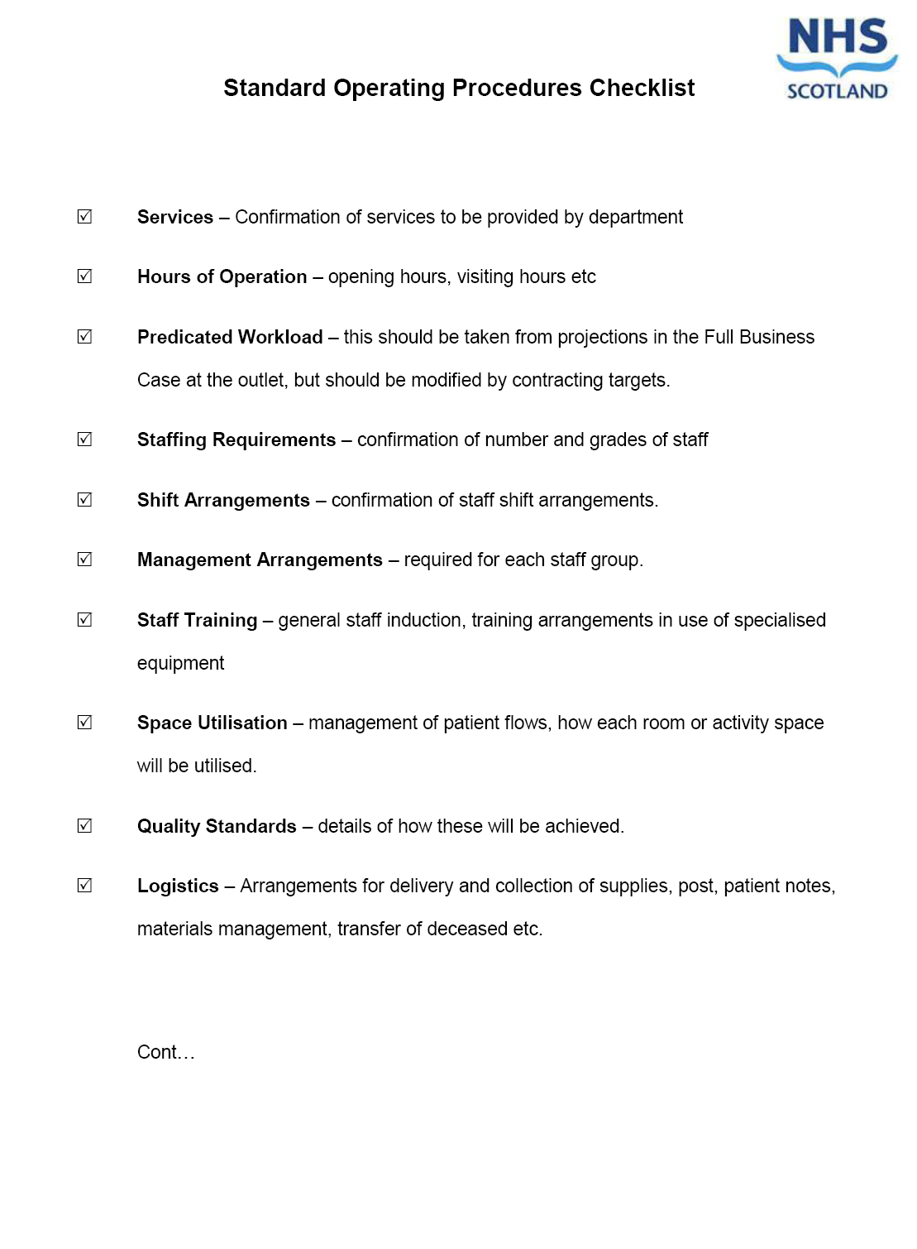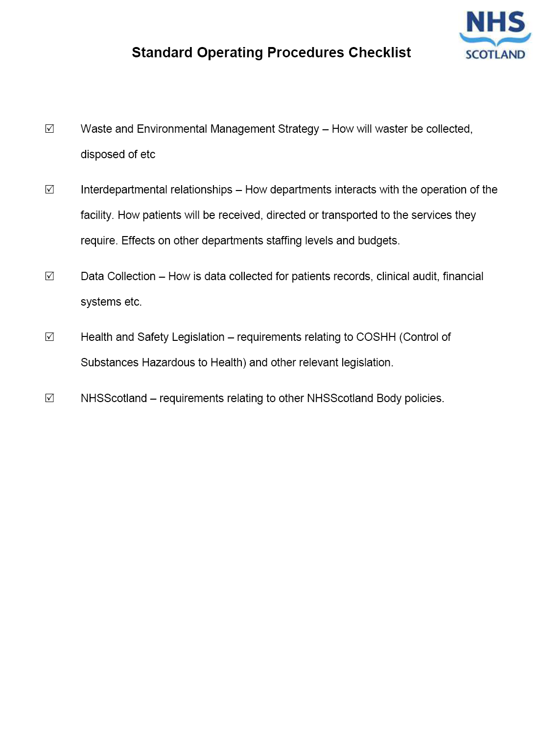
Figure 6: Checklist for Creating Standard Operating Procedures (SOPs)

Communication Strategy
Establishing and maintaining good communication is vital to integrate briefing, design, construction, commissioning and in-use processes.
Those managing the project are likely to be committed and motivated for it to be successful; however, recognition is needed that change is always unsettling and stakeholders transferring from a facility they have known for years will need comfort and reassurance, particularly if closure is anticipated. Frequent 2-way communication is vital as part of a wider organisational ‘change management’ strategy.
It is important for senior managers to:
- Widely circulate project developments on a regular basis in a variety of media to promote ownership & prepare for change.
- Ensure progress information is up to date and readily available.
- Set key dates early and monitor them to assist preparation.
- Encourage and disseminate feedback to assist engagement.
- Manage expectations, monitor progress and morale.
It is recommended that the Client / Senior Responsible Officer (SRO) is involved, underlining the import of communication and engagement.
Suggestions for ways of updating stakeholders include:
- Regular newsletter(s) following the project’s progress.
- Exhibition(s) of project images and photographs.
- Website page(s) with project progress and images.
- Regular talks and site visits.
- Local community / public consultation / PR to limit disruption.
Support may need to be sought to ensure Equality and Human Resource issues are properly considered.
In larger projects / change programmes, a Communications group should be formed who reporting to the SRO. They will be responsible for planning, coordinating and driving forward an integrated communication strategy.

Resource and Budget Plan
The PD / Commissioning Manager should establish, develop, maintain and report on commissioning resources and budget requirements, appropriate to each project stage.
An initial resource and budget estimate is required at the IA stage. At OBC stage an outline commissioning resource and budget plan is required. This will be coordinated with the Commissioning Requirement Brief (CRB) and the Commissioning Master Plan (CMP). This should be reviewed, developed and confirmed by FBC stage. This should be re-validated prior to the outset of key commissioning tasks.
Variances in budgets between Outline, Full Business Case, and prior to the outset of key commissioning tasks, must be carefully monitored and explicitly identified in the overall strategy of the project implementation plan. This is essential to feed into the final Project Monitoring Report (see the Project Monitoring & Service Benefits Realisation guide for further details).
It is crucial that operational managers of the service(s) are involved in this process. As day-to-day resource and budget holders they should have full ownership of and participation in discussions relating to commissioning, training, equipping etc requirements. For example, all income and expenditure projections must take account of ‘double running costs’ in the transition between old and new facilities.
In order to provide detailed advice and support to the commissioning team, one of the key members should be a finance representative.
Depending upon the size of the scheme, it may be appropriate to establish a separate finance working group to co-ordinate and monitor the financial arrangements for the project. This could be the case for each `functional` aspects in a large project / works programme.

Integration with business case and design review process
It is vital that the commissioning process is integrated into the normal business of procurement. The Business Case process will have demonstrated how the project contributes to strategic and business objectives and services will be monitored in-use to confirm realisation.
It will be the responsibility of the Project Director to ensure that the work on commissioning; in defining resources, budgets and standard operational procedures, is integrated into the business case process.
The Commissioning Manager is responsible for contributing to reviewing and reporting on the project brief, Outline then Full Business Cases, including the design proposals in relation to commissioning.
The assumptions underpinning the Business Cases (and ultimately the contract), should be reviewed as part of the commissioning process. This process of reconfirming the business objectives of the project will form an integral part of the wider service planning, whole life costing and support the final Project Monitoring Report on time, cost and quality.
It will be the responsibility of the SRO to ensure appropriate reviews are undertaken. The Project Director, through the Project Manager and Commissioning Manager, will be responsible for monitoring and delivering on business objectives.
During the implementation of a scheme, it is possible that changes in national, regional or local policies may trigger changes to the functional content. The effects of such changes should be explored, quantified and reported by the commissioning team / working group(s). The formal project change control process shall manage these proposed changes.

Migration Plan
The key transfer dates of services into the new facility should be widely communicated and publicised to internal and external stakeholders.
The Migration Plan is a key document for all stakeholders (e.g. table /bar chart), and will demonstrate coordination of key transfer dates for patients, public and staff. It is both dependent on and integral to the Commissioning Master Plan (CMP). It can be combined or separate from the Equipping Plan. An example migration plan is shown in Appendix B.
Key milestones, such as completion of the commissioning process and first patient day, should be clear. Local community, GP’s and other key groups should be encouraged to visit the facility on open days.
Patient representative groups and other key stakeholders should have been consulted about the design of the facility to ensure that it meets their needs. These groups shall also be kept up to-date with the details of the Commissioning Master Plan. Requests for visits shall be well organised and permitted wherever possible. Whilst this may be resource intensive for large projects it is important that user groups are properly engaged. Such groups may also be engaged to assist in communicating with service users.
The Migration Plan will need coordination with the Equipping Plan, i.e. transfer of existing / delivery of new equipment. If a large percentage of fixed equipment is to be transferred, a considerable amount of resource and support will be required to survey and coordinate with designers / contractors to dismantle and refit in the new facility.
The Commissioning Manager / team shall ensure commissioning risk assessments are undertaken as appropriate to scale / complexity. For example, the safety impacts on the local community of large deliveries, or moving large amounts of equipment in partially occupied facilities. It is vital to have procedures in place for maintaining adjacent clinical and other critical services safely; plus contractor protocols and contingency planning for when things inevitably do not always go to plan.

Phased or Sectional Occupation
Many projects require occupation of the new facility to be undertaken on a phased basis. This will be reflected in the Commissioning Requirements Brief (CRB), Commissioning Master Plan (CMP) and Migration/ Equipping Plans. Phases will require close liaison between the Project and Commissioning teams on contracts, access, security, plus the risks of any potential construction delays.
Under one or more contracts, a number of different buildings may be handed over, on different dates. Arrangements must be in place to bring these facilities into use, as they become available, unless there are safety, operational or clinical reasons why this cannot be done.
Standard Operating Procedures (SOPs) should take full account of these arrangements and ensure that the relevant staffing, budgets and delivery arrangements are in place to cope with this eventuality.
A facility handed over to users in phases or sections require additional consideration of the following:

- Contracts - arrangements should be in-place prior to tendering, and need to be explicit prior to signing.

- Safety - access and handover protocols needed for each phase/ section, as they are released by the contractor.

- Risk & Benefit assessments - potential for extra cost, e.g. fire, insurance, O&M manuals, maintenance; but also support of key activities e.g. staff training, health & safety, infection control, technical commissioning, SOPs.

- If areas through which users have to pass are still under the control of the contractor, potential implications for fire, security, insurances etc, plus additional delay /cost risks

Decanting
‘Decanting’ is the term used to describe the temporary relocation of facilities, for example to permit refurbishment or closure of an old facility before the final accommodation is ready for use. This has implications for stakeholders and support services throughout pre, during and post decant periods.
Full account of this must be reflected in the Migration Plan, the Commissioning Master Plan (CMP), and Commissioning Requirements Brief (CRB) plus Standard Operating Procedures (SOPs). Decanting will require close liaison between the commissioning and project teams on potential construction delays.
Figure 7: Typical Equipping Strategy Diagram
Strategy for disposals, removals & waste material in place
Asset ID / tagging and recording policy in place
Security Strategy in place
Selection processes in place e.g.VfM, TADs, HAI, Sustainable criteria
Procurement Strategy in place for purchasing new items
Procurement Strategy in place for replacing any items prior to the move
Items for transfer clearly identified
Equipping Strategy

Equipping Strategy
The Project Director, supported by the Commissioning Manager, who in turn may be supported by an Equipping manager, shall establish, maintain and report on the Equipping Strategy /plan, as appropriate to the size/ complexity of the project, and for each stage.
The Equipping Strategy should consider the items identified in Figure 7. At initial stages identify the key elements, followed by an outline Equipping plan with budget at Outline Business Case stage. This should be reviewed regularly, developed, e.g. with an Equipping Responsibility Matrix (see Appendix D), confirmed at Full Business Case, and finally validated just prior to the outset of equipping.
Variances in budgets between Outline and Full Business Case, and prior to the outset of equipping, must be carefully monitored and explicitly identified in the overall Equipment Strategy and Implementation Plan.
Professional equipping support should be sought, particularly for large or complex projects to assist on procurement policy / OJEU etc. NSS Health Facilities Scotland (HFS) equipping team can provide this. An HFS Equipment manager, technical and product support services are available as a cost neutral service to the NHSScotland Board /client.
The Commissioning Manager should retain a pre-agreed equipping contingency budget for the above eventuality, plus any last-minute or overlooked items which need to be ordered urgently at handover.
Operational and maintenance training should be coordinated effectively as part of Equipping Strategy, to ensure that all staff members receive appropriate training in order that the equipment can be in-use when new facilities open for service. This is particularly onerous with lots of new systems or equipment, plus for large volumes of staff. Planning for this training should be incorporated into the overall Commissioning Master Plan (CMP).

Equipping Processes
The initial equipment list is based on the mandatory NHS Estates Activity DataBase (ADB) room data sheets (RDS) and should be signed off by users during the design briefing period of the project. This provides the basis for the project and design team to develop their initial proposals and costs, including Equipping Strategy.
The commissioning team, supported by Equipping manager, will review the ADB room data sheets, extract and develop equipment schedules. They must confirm the ADB equipment groups 1-4, plus identify any sub-sets, e.g. transferred items, or budget holder if new:
Group 1 | Fixed items supplied and fitted new, via project construction contract. For example: sanitaryware, cabinetry, worktops, racking, electrical and data points, x-ray, autoclaves, fridges, soap dispensers, clocks etc.
Group 2 | Fixed items with space, construction or engineering requirements and are fitted within the contract but supplied under separate arrangements.  For example: transferred fixed equipment, x-ray, dental chair, autoclaves, fridges, racking, soap dispensers, clocks, furniture etc.  (Group 2Tx, 2Ax or 2Bx are equipment sub-sets, where specialist fitting is deemed necessary, e.g. ICT, linac, x-ray, dental, lab etc.)
Group 3 | Non-fixed items, but with space, construction or engineering requirements supplied and installed after handover, outwith the construction contract. For example: new furniture, transferred non-fixed equipment, racking, mobile clinical equipment, mobile x-ray, beds etc.
Group 4 | Loose items, without space, construction or engineering requirements supplied and positioned after handover, outwith the construction contract. For example: transferred loose equipment, new phones, computers, bins. Often not on room data sheets, but they have storage / ICT implications.
Figure 8: Typical Equipment Group definitions

Note: client selection of Groups 1, 2 & 3 for the same equipment can vary, e.g. racking, dependant on project budget and contract.

If not using the sample Equipping Responsibility Matrix as developed by HFS equipping team in Appendix D, or similar; the following budget related sub-sets should be identified for ADB Groups 2-4 equipment:
- T – Transferred: equipment currently in-use & will move to new facility
- A – New: supplied by client, via project Commissioning budget
- B – New: supplied by client, via non-project separate budget(s)
- x – Specialist fitting: added to Group 2 for any above. For example, transfer of CT scanner on existing manufacturer’s maintenance contract, by their approved mover, to retain warranty: group 2Tx .
Group 2 equipment is supplied outwith the construction contract, but fitted as part of it. Group 2 requires careful liaison to fit with the contractor’s design and programme. For example, if any space, construction or engineering requirements are not provided on time, extra costs /delay can occur. Storage is often an issue, so supply of just-in-time batches, may be required. Fitting, and commissioning, by the contractor can need long lead-in periods prior to service migration; therefore not all items will be appropriate for transfer.
Group 2 fitted outwith the project construction contract (sub set x) requires particular consideration and liaison to suit the contractor’s proposals/ programme, as supply and fitting is not directly via the contractor, the risk of claims for extra costs /delay are high. This option is usually only for highly specialist equipment with built-in maintenance / commissioning needs, often by the manufacturer, e.g. imaging. A risk assessment must be carried out to ensure VFM, if any specialist fitter is not contracted as domestic sub-contractor.
Effective liaison between the Equipment manager, Commissioning Manager and Project Manager is essential to successful equipping.
The contractor’s room design and technical proposals need to be regularly reviewed against the Equipment Strategy. This allows updates to the budget, Equipment Strategy/ CMP, but also advice and verification of design proposals suitability, e.g. space for equipment maintenance. The room design must be fit-for-purpose, but also flexible to suit changing equipment needs, as far as practicable.
ADB provides each equipment item with a code and a default Group 1-4. Dependant on contract and budget, this group can be varied by agreement in final contract, e.g. using Equipment Responsibility Matrix. Some items, e.g. storage racking or lockers, are better VFM as Group 1, rather than default Group 2, but indeed may be best VFM transferred as Group 3 out with the building contract.

Equipment Selection
Equipment qualities, e.g. operability, maintainability, lifespan, and sustainability, are an intrinsic part of the mandatory whole life cycle value for money (VFM) assessment. The specification of quality requirements and their assessment must be undertaken in consultation with the users, the Therapeutic & Access Design Strategy (TADs) group, and all relevant Champions e.g. Sustainability, HAI, Equality. Standardise wherever practicable across all departments, to benefit quality, costs, maintainability, flexibility & sustainability.
The selection of equipment is a time consuming process, from assessing offerings from different suppliers, to surveying all potential transfer items, and complying with OJEU / NHS procurement policy timescales. It is essential that equipping is mapped onto the early CMP, and then refined to fit in with procurement and supplier lead in times and contractor’s deadlines for design, supply and commissioning.
Equipping Note:
It is essential that Clinical, Infection Control, Sustainability, Facility, Manual Handling & Equality requirements are fully considered during procurement. VFM means capital cost is often dwarfed by operating and disposal costs. Operating costs must include: energy, maintenance and replacements over agreed lifespan, of not just the equipment, but also effect on overall building systems, e.g. an inefficient fridge increases room ventilation / cooling needs. ( EU rated A+ approx twice energy use of A+++ <22 kW/l/yr fridge)

The interior design of the facility, will influence, and be influenced by, the equipment selection. The architect or a specialist interior designer will, in conjunction with user groups, agree colour schemes to fit a Therapeutic & Access Design Strategy (TADS) plan, as well as key transferred items. This concept design will include guidance for complementary furniture e.g. tables, chairs, textiles, for each area.
Initial focus should be given to key pieces of equipment which could have a significant impact on the design. These may include Imaging, Decontamination, Pathology, Pharmacy, Operating Theatre and other equipment which have major services, space, loading, commissioning or access requirements. Designers and Contractors will require relevant information at an early stage in order to accommodate the equipment which will subsequently be procured. Consideration must also be given early to mitigating high risk equipment selection, e.g. suitability for transfer, any items where delays are highly likely.
Group 2, and particularly specialist-fitter equipment (sub-set x), need particular consideration; to ensure they are mapped early into CMP. These items risk incurring contract delay / costs, and must be specified, ordered, delivered, and especially if ‘x’ fitted, to suit the contract programme and design proposals. Potential for variance to this must be carefully monitored and reported to the Project Manager by the Commissioning manager in their risk register.
Use of an Equipment Responsibility Matrix (ERM, Appendix D) or similar is recommended to ease communication, monitoring and budgeting throughout the selection process. For example it allows testing of VFM if selected equipment items are moved from ADB Groups or into varying sub-sets of supply / fitting and maintenance.

Equipment & Furniture Removal & Delivery
Good planning, coordination and communication is paramount to ensure a smooth transfer of furniture and equipment. It requires to be appropriately resourced for the project, and incorporated within CMP and contract master programme, e.g. Group 2 supplies need to suit contractor’s installation dates, and Group 3 -4 supplies need to suit handover dates, however these often vary if programme runs late/ early
Phased delivery of furniture and equipment is often required. This can be due to the large volumes, logistical constraints for access and storage, contractor’s Group 2 equipment programme, or a staged opening of the operational facilities.
If large amounts of Group 3 -4 furniture and equipment are to be moved, it is advisable to engage specialist removers who have experience working with and in healthcare facilities, including HAI risk.
Transfer of equipment from existing operational facilities is likely to occur immediately prior to occupation of the new accommodation and deliveries and installation/placement of new equipment should be scheduled to be completed before the transfer commences.

Storage of Furniture & Equipment
The temporary storage of furniture and equipment should be avoided where possible as it results in double-handling with additional costs and will reduce the useable warranty period when equipment is eventually put into use. Good supply scheduling will generally obviate the need for prolonged storage. If temporary storage is essential, the area should be secure and clean, the risk of water or other damage low, and location should be accessible to the new facility and for deliveries.
Spare client space may be utilised as temporary storage area for furniture and equipment. This or any alternative storage option, e.g. local warehousing, early handover of an area in new facility, should be detailed by FBC, including related cost allowances and risks.
Matters to be considered in respect of storing furniture and equipment are:
- Ensure security issues are managed appropriately.
- Cleaning and decontamination of equipment.
- Plan in place to have all medical equipment checked by Medical Physics, Anaesthetic and Technical Staff.
- Asset tagging is best done at this stage.

Equipment & Furniture Placement
The Commissioning Manager is responsible for placing/ installing all Group 3-4 furniture and equipment. Labelling with the room number and the code shown on the 1:50 room drawing, by the supplier or immediately on receipt, enables a quick and easy installation.
Some items need to be tested in place to confirm they work properly, e.g. fridges, which operate at a certain temperature range. Many items require to be monitored in their new location, to ensure the technical commissioning e.g. ventilation balancing by the contractor, is accurate, will work, and is monitored appropriately in operation.
Medical equipment requires Acceptance Testing in line with the NHS Scotland Body’s Medical Physics Department’s policies. Small items of medical equipment therefore are often delivered to the Medical Physics testing workshops rather than directly to their final location.
For all potential transferred equipment, the space, services, logistics etc requirements need careful surveying and compatibility checking, e.g. electrical, wall fixings, plumbing and dimensions. Non compatible equipment is unlikely to be suitable for transfer to the new facility.

Equipping a Room
Activity DataBase (ADB) is the NHSScotland mandatory briefing software. ADB provides generic coding and graphics, allowing every room to be fully scheduled and drawn at 1:50 scale. This room layout sheet (RLS) should be displayed in the room prior to equipping, for easy placing and checking.
To assist locating a room, each should have a unique number consistent with that shown on the design drawings at 1:200 and 1:50 scale. 1:200 drawings should be placed at entry to each floor.
Staff often bring additional, unscheduled items, these will require approval by the Commissioning Team. If accepted, these will often require improvisation to ensure compatibility with overall designs.

Other matters to be considered in respect of placing furniture and equipment are:

- PAT testing – must be scheduled/ resourced
- Asset ID/ registering/ management
- Cleaning and Infection Control.
- Management of keys, accessories and user manuals etc.
- Training requirements

Site Visits and Training
Pre-handover, the facility is technically and contractually a site run by the contractor. Health and Safety (H&S) for staff making site visits is essential. The commissioning team should be trained on H&S procedures on site and they should put in place strict controls on access and protocols for staff conduct on site visits. Users must not enter the site without the explicit agreement of the Project Manager (PM) and the Contractor.
As the facility comes closer to completion, site visits for staff training and familiarisation should be organised by the Commissioning team well in advance with the contractor and PM. Development of CMP is particularly important as the contractor often requests areas to be “locked down” to avoid mess / finishes deterioration etc, just prior to handover.
The run up to Handover is often frenetic and has many competing priorities; however the importance of on-site operational and maintenance training and documentation cannot be underestimated. A facility handover cannot occur without fit-for-purpose and safe operation.
At pre-handover, strict management of access is essential, particularly for client, users, third parties, nominated sub- contractors or ‘specialist fitters’ e.g. x-ray, (equipment group sub set x). All will require the contractor’s permission to be on site/ ‘permit to work’, unless they become a domestic sub-contractor and are under the contractor.
Post Handover, the contractor should observe similar strict controls and protocols for their workers and visits to the new care facility, which is now under the control of the client. It is easy to underestimate the number of people who will wish to visit the facility during the commissioning period. The Commissioning Manager should be made responsible for controlling access post handover, until all users are in. See 4.6 on Phased or Sectional Occupation.

Technical Commissioning
Technical commissioning primarily involves bringing the mechanical and electrical services and equipment in the building into use as well as testing of the building fabric, acoustics, below ground drainage, fire hydrants etc. This must include setting and monitoring of targets e.g. NHSScotland Design Energy Performance (NDEP) will include bespoke kW/m2 targets), with HFS support for each facility. NDEP must be monitored and updated min. annually, to ensure operational optimisation in our ever-changing service need / climate.
Commissioning is undertaken by the contractor and relevant sub-contractors. It will be the task of the contractor / design team to ensure that all services and equipment provided under the contract are operating according to the contract specification and be consistent with the user requirements in the Commissioning Master Plan.
It will be the responsibility of the Project Manager to ensure that the contractor draws up a full programme of technical training and demonstrations as part of this process. Dates and times of these will be agreed with the Commissioning Manager, who will arrange for the relevant personnel from the users of the facility to be in attendance, so that they can understand how the facility/ equipment operates.
It will be the responsibility of the contractor, under the terms of the contract, to ensure that all technical manuals, Health & Safety, CDM and literature relating to the operation and maintenance of the facility, equipment and plant are passed to the Commissioning manager for review, then final submission, to the format and timetable agreed in the Commissioning Master Plan. User manuals, in ‘non technical speak’, are required to support staff to use the facility safely and effectively. The Project Manager must ensure that this is done.
An extract from a typical Technical Commissioning Plan is provided for illustrative purposes in Appendix C.

Fire Safety
The procedure to be adopted in relation to Fire Safety during the lead in period to commissioning is contained within CEL 11 (2011), which introduces the Fire Safety Policy for NHSScotland 2011. Although the policy often refers to new build premises, the same principles apply to refurbished facilities as detailed in NHSScotland ‘Firecode’ publications e.g. SHTM 81.
CEL 11 (2011) provides both policy and the mandatory requirements covering the commissioning period of premises prior to occupation. In particular Annex C, provides fire safety management guidance through the critical transition period of commissioning. Compliance with CEL 11 (2011) and current Technical Standards, is deemed to satisfy the Fire (Scotland ) Act 2005, its regulations and amendments.
NHS MEL (1997)80 ‘’Health and safety issues in NHSScotland” states safety of patients, staff and visitors is to be given high priority at NHS board level, as is meeting statutory obligations on health and safety. Fire safety is not a stand-alone issue but one to be risk managed as part of an overall approach on health and safety matters.
Key fire safety management and equipping decisions must be made and relevant fire safety information gathered and developed in plenty of time prior to hand over. Key dates for these should be highlighted as part of the overall coordination in the Commissioning Master Plan (CMP). A supplementary more detailed programme may also be required for larger, complex or phased projects. This may also require to cover safety of existing as well as new facilities, e.g. partial decants. Appropriate time is required for input, coordin-ation and approvals across all parties, particularly if multiple organisations.
The operational development of local policy, procedures and training of staff prior to opening a facility to patients / public, will normally be undertaken by the fire safety advisor(s), in consultation with key management staff. However clear responsibilities, roles and functions required for this will be defined and coordinated through the Commissioning Manager, to ensure consistency and a safe transition into, or from, an occupied, operational health & care facility.
The initial requirement at start of fire safety commissioning is to check and confirm to Commissioning Manager that fire safety design, and construction, is appropriately incorporated for the facility / stage. This should be done in a written report, so any potential issues can be addressed.
Loose fire fighting equipment can be Equipment Group 1, 2,or 3. See Figure 8 above for definitions. Early engagement by all parties should agree an optimum project specific arrangement for their supply, maintenance and replacement/ addition of fire equipment.

Health Information & Technology
The initial requirement at the start of health information and technology (HI&T) commissioning is to check and confirm to the Commissioning Manager that HI&T design and construction is appropriately incorporated into the facility / stage. This should be done in a written report so that any potential issues can be addressed.
An element of the above report is a confirmation of the IT infrastructure, e.g. cable trays, containment etc, and HI&T installation extent, included within the construction contract. Refer to section 4.8, for guidance on equipping process, VFM and risks associated with HI&T, particularly if not provided via a domestic subcontractor under the construction contract.
The following provides a list of typical things that should be considered at design development stage. It provides a useful checklist and reminder of the scope and complexities of commissioning this technology:
- Will there be a single IT network, or will separate clinical / academic facilities, or other multiple IT networks, be required?
A single, shared network will need early capital expenditure on HI&T infrastructure and hardware to support the facility’s commission prior to handover. A separate facility IT network is likely where FM is provided via a commercial contract e.g. PPP/ NPD/ Hub.
- Are multiple networks secure and/ or compatible?
- Has the hardware specification been checked to ensure that it is compatible with NHS systems?
This may require direct procurement of switches and chassis, although elements of these are required for Building Management Systems (BMS) and for communications systems such as Automated Guided Vehicles (AGV’s). If these are part of a single network then, as above, early procurement and installation will be necessary, plus consideration on warranties, security and insurances are required for use of high value equipment in a construction site.
- What is the scope / need for hard wiring, wireless provision and mobile coverage?
In terms of device use, consideration needs to be given to selection of fixed and portable devices for both clinical and Estates/FM use, particularly where interfaces with other systems e.g. BMS/FM First/AGVs.
- What data storage, security and back-up is required, particularly for clinical data/ images?
There are increasing interfaces between recording technology and server storage capacity. Departments such as Medical Illustration, Audiology, Child Protection all have requirements to store recorded video images for prolonged periods via fixed cameras, and interfaces with the network require to be assessed and accommodated.
- What voice/ telecoms systems have been considered, including provision of contingency back-up lines?
- Is provision for incoming ducts and IT/ comms room space adequate?
- Has the design of patient areas, i.e. wards, included for electronic information screens at or close to nurse bases to allow for displaying of patient locations etc?
- Has provision for similar screens, for patient calling, been included in waiting and out-patient areas?
The HI&T commissioning timelines are dependent upon the amount of integration between building systems and the clinical network. It is vital to get final design / as built data layouts as early as possible in order to compile the patching schedules. Therefore delivery of these layouts should be identified as a key delivery milestone within the commissioning master plan programme.
Comms Rooms and IT/ Hub room cooling should be another key milestone to ensure that servers/switches are within a controlled environment when in-use and security access systems should similarly be in place/commissioned prior to going live.
NHS network N3 access agreements need to be put in place as early as possible and Anti-virus software has to be to NHS specification, to ensure that going forward patches can be applied as required.
Integration of alarms and life safety systems with the clinical network may be necessary via pop-up screens on NHS Boards etc. and at PC’s at locations such as receptions, nurse bases and touchdown desks where a dispersed nursing model is utilised, and these may include the following:
- Medical Gas alarms
- Nurse call messages
- Fire alarm notifications
- Door entry systems
- AGVs and pneumatic tube delivery messages
- BMS comfort controls
These integrations may need “fast access” signs on protocols for acceptance or cancelling of alarms and should be considered in the design stage and fully implemented during commissioning stage.

Therapeutic & Accessible Design Strategy (TADs)
Section 4.10 above states the selection of equipment, furniture, textiles etc, is to be consistent with a Therapeutic & Access Design Strategy (TADs).
The purpose of a TADs is to plan, commission and realise, the interior and exterior design and all fittings as part of a seamless and integrated environment to ensure key therapeutic and accessible objectives for each project are delivered, e.g. health promotion, accessibility, greenspace, art, intuitive wayfinding, signage, sustainability, maintainability. See Figure 9 below:
Figure 9: Typical TADs Considerations Diagram

The initial development of the project TADs plan is during design stage as a response to the brief i.e. ACRs and Design Statement, but its development should be shaped and then taken on by the Commissioning Team to ensure realisation of the design concepts.

To ensure operational outcomes meet the diverse needs / inputs for successful health and care requirements, the Commissioning Team will require input from the TADs working group and/or the relevant champions, e.g. HAI, FM, Arts, Health Promotion, Design, Sustainability, Greenspace, Equality/ Access, Users, and procurers (e.g. NSS NP/HFS Equipping team).

Artworks & Greenspace
The therapeutic benefits of artworks, and in particular greenspace, to aid and de-stress patients, carers, staff and the wider community, are well documented. Scottish Government policy CEL 1 -2012, and its addendum Health Promoting Health Service encourage the active promotion of health and wellbeing for patients, staff and public.
The initial requirement at start of art and greenspace commissioning is to check and confirm to Commissioning Manager that TADS plan, and construction, is appropriately incorporated for the facility / stage. A written report will enable any potential issues to be addressed.

Figure 10: Typical Art /Greenspace Considerations Diagram

Access & Wayfinding
An Equality and Access Statement should be developed as part of the TADs, supporting an integrated approach to Equality Act public duty delivery. Commissioning must build on and coordinate with this strategy.
The initial requirement at start of access & wayfinding commissioning is to check and confirm to Commissioning Manager that the TADs plan and construction is appropriately incorporated for the facility / stage. A written report will enable any potential issues to be addressed
Access & intuitive wayfinding, both internally and externally, are very important for patients and visitors who often attend health & care facilities in great stress. Detailed guidance and checklists are available at www.hfs.scot.nhs.uk/publications-/ ; including: www.hfs.scot.nhs.uk/publications/wayfinding-v4.pdf; www.hfs.scot.nhs.uk/publications/dementia-checklist-v1.pdf; www.hfs.scot.nhs.uk/publications/access-audit-checklist-feb-2000.pdf
Required wayfinding signage should comply with NHSScotland Corporate Identity Guidance. A design toolkit and further detailed information can be accessed at www.nhsscotlandci.scot.nhs.uk.
Some key access & wayfinding considerations include:

- Allow sufficient time for obtaining planning permission for external access/ lights /signage from the Local Authority.
- Agree routes, parking, access, delivery points and WC facilities policies in time for the relevant signs to be ordered.
- Arrange for temporary signage for a facility closing, as a result of new development, so the public are well-informed.
- Ensure new road signs agreed and installed by the Roads/ Highways Department and only unveiled to coincide with the transfer of services.
- Ensure coordination of Health & Safety, Fire and statutory signage e.g. no smoking, cctv/ data protection.

Pre-handover and the ‘Snagging’ list
Upon completion of the contract / pre-handover, the Project Manager working with the design team, Clerks of Works/ Verifier etc., will recommend that the facility be handed over to the client. Often, even with ‘zero defects’ policies, a list of outstanding small works is required; this is commonly referred to as the contractor’s ‘snagging list’. The Commissioning Manager should review and report on any missing elements, ongoing risks etc.
Outstanding works may be completed by the contractor(s) after the formal handover of the building. It is important to note that the building has now passed out of the ownership of the contractor and into that of the provider. The contractor and the client must therefore agree rules governing security and access to the facility while snagging is being undertaken. Snagging may consist of minor works such as touching up paintwork, fitting door furniture etc. but may in some cases need more significant repairs/snagging to be carried out which may require planning / risk assessments and temporary relocation of services.
During this period, it is essential for the Commissioning Manager to be aware of the areas in which the contractor is still undertaking these works so that care and safety precautions can be taken.
A formal process of monitoring snagging, or any additional works, should be agreed, e.g. agree a list of items jointly with the contractor and arrange weekly reviews of ‘completed’ items until all are resolved. All outstanding items will be prioritised to ensure high risk snags (i.e. any preventing a service moving or making it very difficult for it to operate) are completed first.

The Post-handover Period
The main task after building handover by the contractor is to move clinical and support services into the new facility. The first consideration after handover must be to ensure that the building is secure and appropriate insurances in place where required, as it may be some time before users actually occupy the building.
Establish Post-handover procedures, appropriate to the project scale:
- The facility is locked up out of hours or when it is known that no one will need to be inside it.
- There is a security presence, whether in-house or contract, in the facility, if appropriate.
- Regular checks are made to detect any leaks or other problems that might delay bringing the facility into use.
- There is a ‘signing in’ book, so that access can be controlled and it is always known how many people are in the facility at any time.

After the contractor has completely finished, or finished the majority of snagging works, all floors etc are to be cleaned in accordance with the Maintenance Manual. Several days should be allowed for this activity depending upon the size of the facility. It is best to pre-agree the time to be taken for this and for it to be recorded in the commissioning master plan.
It is possible that some items or parts of the specification have been omitted by the contractor in error. These should be identified by the Project Manager and dealt with by the Contractor. The Commissioning Manager must be made aware of the extent of the works and any impact of such works on the commissioning master plan.
Requests for works which fall outside the original brief should be agreed with the Client / Senior Responsible Office through appropriate change control processes, and should be dealt with as part of normal maintenance or minor capital works through local NHSScotland Body procedures. These works should not be deemed part of the contract or commissioning costs unless it is decided that not to undertake the works would prejudice the effectiveness of patient care. The final adjudication on this should rest with the Client / Senior Responsible Office. Within a PPP project a formal Change Order may be raised.
The commissioning team should assess any post-contract works required by the users. These should be matched against the brief and action taken if it is decided that the contract has not met the brief.

Decommissioning Redundant Facilities
Decommissioning is the process by which a redundant site or facility is taken out of operational use following the transfer into the new facility. The new owners of the site may influence this process.
A policy for the disposal of all surplus assets must be agreed, in order that they can be redistributed elsewhere in the NHSScotland Body, recycled, sold or scrapped. The policy should refer to the Procurement/ Financial Standing Orders and/or the NHSScotland Property Transactions Handbook in order to ensure that the process is administered correctly. This shall also involve the process by which unwanted items could be sold to staff. This again requires careful management.
It is useful to identify a central storage facility for surplus assets where equipment can be transferred after the transfer and closure of each department. An inventory shall be kept so that the assets can be removed from the NHS Board’s asset register when necessary.
If services are to be transferred from old buildings or another site on a phased basis, ongoing maintenance and security will be necessary during this period.
Temporary signs should be provided indicating departments which have closed and been transferred. The local police should be informed of closures in advance of the event.
Measures should be taken to make safe any plant or equipment not to be removed. Lifts and other plant should be deactivated and sealed off. Any large built-in refrigerators will need to have their doors removed and consideration given to the removal/disposal of hazardous materials/medical records and clinical waste.
Ensure early consideration is given to amend/ phase out all relevant contracts, e.g. maintenance, utilities etc.
This process must be well managed for large schemes and responsibilities well defined. A contingency budget is essential.

Closed Facilities
Once the facility has been closed, all redundant facilities must be secured, signposting removed (particularly to emergency facilities), security arranged and arrangements made for disposal.
Given the potential fluctuation in land values or complexity over land sales over the life of even a relatively small scheme, contingency plans should be prepared if a site cannot be disposed of shortly after it has been vacated.
This risk should be assessed as part of the full business case and relevant allowances made for the security of the site and any other associated costs as part of the project contingency sum.

Public Relations
It is essential that the NHSScotland body’s Communications Team is involved in drawing up the PR/ communications strategy. They can advise on the best way of generating publicity through the media to ensure maximum coverage, appropriate communication to the public on progress of the scheme, and the programme for opening services in the new facility. Individual NHSScotland bodies should also liaise with the Scottish Government Health Directorates Communications Team regarding their proposals.
It is important to capitalise on the interesting features of the new facility such as the establishment of a new service, the original design of the facility, or the art installations.
Public relations should be a high priority on the Commissioning Manager’s work plan to ensure that patients and service users know where to go, particularly for A&E services to ensure that the public always know where to get emergency help. A Communications Strategy should be developed to address this issue using media, advertising, and promotions.
By ensuring steady coverage of the scheme there is an opportunity to inform the general public of what is going on and keep them in touch with developments throughout the life of the scheme.
All members of staff who will have contact with the media or who will be undertaking presentations should have some training in how to answer questions and put across the key messages.

Operational Handover Plan and ongoing optimisation
Commissioning is not just a single point in time when all systems are ‘optimised’ e.g. handover day. It is a continuous process that ramps up from OBC to Handover, but also must be on-going, e.g. min. yearly reviews, to ensure operational optimisation in our ever-changing service need / climate.
The initial requirement is to check and confirm to the Commissioning Manager that the Contractor’s Operational Handover Plan is appropriately robust for the facility / stage. A written report will enable any potential issues to be addressed
It will be essential to maintain the commissioning team for at least three months after the facility is operational. The team and the Commissioning Manager should be available to deal with issues from occupation and use of the new facility. The Soft Landings Framework – ‘Stage 4: Initial Aftercare’, provides further details.
FM and operational management must work alongside the commissioning team to ensure that day-to-day queries or problems can be dealt with by managers of the service in the normal way.
It is essential during the construction phase that strong working relationships are established between the client and contractor / FM teams to ensure that the transition through commissioning to operation of the facility works well and feedback is given to build a longer term partnership relationship.
Handover needs to be a formalised process with appropriate sign off by the relevant accountable individuals. Appropriate record keeping of all handover procedures should be maintained.
Site Management and who will be the direct contact for PPP/ FM provider discussion should be agreed well before transfer. All contractual obligations, protocols, communications channels and indeed the teams, need to be understood and final arrangements in place in plenty of time prior to actual handover, e.g. helpdesk protocols; monthly reports (samples) review; escalation protocols & processes. Appropriate monitoring / reviews are also needed.

Official Opening
The official opening of the facility should be undertaken about three to six months after full occupation has been achieved. This provides an opportunity for staff to become used to their new working environment and any residual post-contract issues to be dealt with. The arrangements for the opening shall be the responsibility of the Commissioning Manager.
NHSScotland Bodies shall produce their own local guidelines for dealing with official openings. The person who should undertake the opening usually depends on the size of the facility and its status within the local community. As section 4.26 above, the Communications Team will be able to advise on this.
The official opening should be one of the key dates on the master plan and shall be publicised and arranged well in advance to provide maximum impact.
To open the facility, and depending on impact, it will be appropriate to select either the chairperson of the provider, a local dignitary e.g. MSP, MP, MEP, Councillor; or alternatively a media celebrity with local links,.
For very large schemes, it may be appropriate to approach a senior member of the Government or a member of the Royal Family to undertake the duty. Protocol relating to Royal or Government visits shall be checked carefully with the appropriate private office. Many months notice is required to arrange this. Informal contact should be made with the Ministerial / Royal Private Office in the first instance. It is advisable to have a list of second and third choices on standby.
The list of official opening invitees should be carefully selected to ensure that it represents a good cross-section of the staff and team involved in the design, commissioning and construction of the facility.

Appendix A - E

NHSScotland
Commissioning Process
(NCP)

Appendix A – Sample Commissioning Risk Register 53
Appendix B – Sample Migration Plan 55
Appendix C – Sample extract from a Technical Commissioning Plan 56
Appendix D – Sample extract from an Equipping Responsibility Matrix (ERM) 57
Appendix E – Schedule of Activities 59

1. Identification |  |  | 2. Assessment |  |  |  | 3. Control
Risk No | Risk Description | Financial / Non-Financial / Unquantifiable | Consequence (C) | Likelihood (L) | Risk  (C x L) | Owner | Proposed Treatment / Mitigation | Action Taken
 |  |  | (1 - 5) | (1 - 5)
COMMISSIONING RISKS
1.0 | Commissioning risk
1 | Delay to migration programme due to unforeseen delay in construction process |  |  |  |  |  | Allow contingency period within migration period and adopt an early warning system.
2 | Delay to migration due to adverse weather conditions |  |  |  |  |  | Develop contingency plan for any delay to the programme and liaise with project team on construction progress
3 | Issues arising with the delivery or commissioning of new equipment prior to migration |  |  |  |  |  | Identify suitable person to manage deliveries and storage on site
4 | Staff are not ready for the new facility, e.g. domestics, estates |  |  |  |  |  | Assess need and develop recruitment and training programme
5 | Staff unavailable to support migration over the weekend |  |  |  |  |  | Prepare register of staff availability and appropriate communication strategy
6 | Loss of key staff |  |  |  |  |  | Identify key staff and identify their availability at key stages. Also develop contingency plan for any unavailability
7 | Issue arising from disposal of surplus equipment prior to building closure |  |  |  |  |  | Develop disposal strategy and ongoing monitoring process
8 | Risk of patient information being lost during migration |  |  |  |  |  | Develop information transfer strategy that complies with appropriate information governance policies.
9 | Failure to ensure security of vacated site |  |  |  |  |  | Develop security strategy for vacated site
10 | Delay in demolition of vacated building, e.g. added costs |  |  |  |  |  | Develop demolition plan which aims to appoint demolition contractor at least 6 months prior to handover

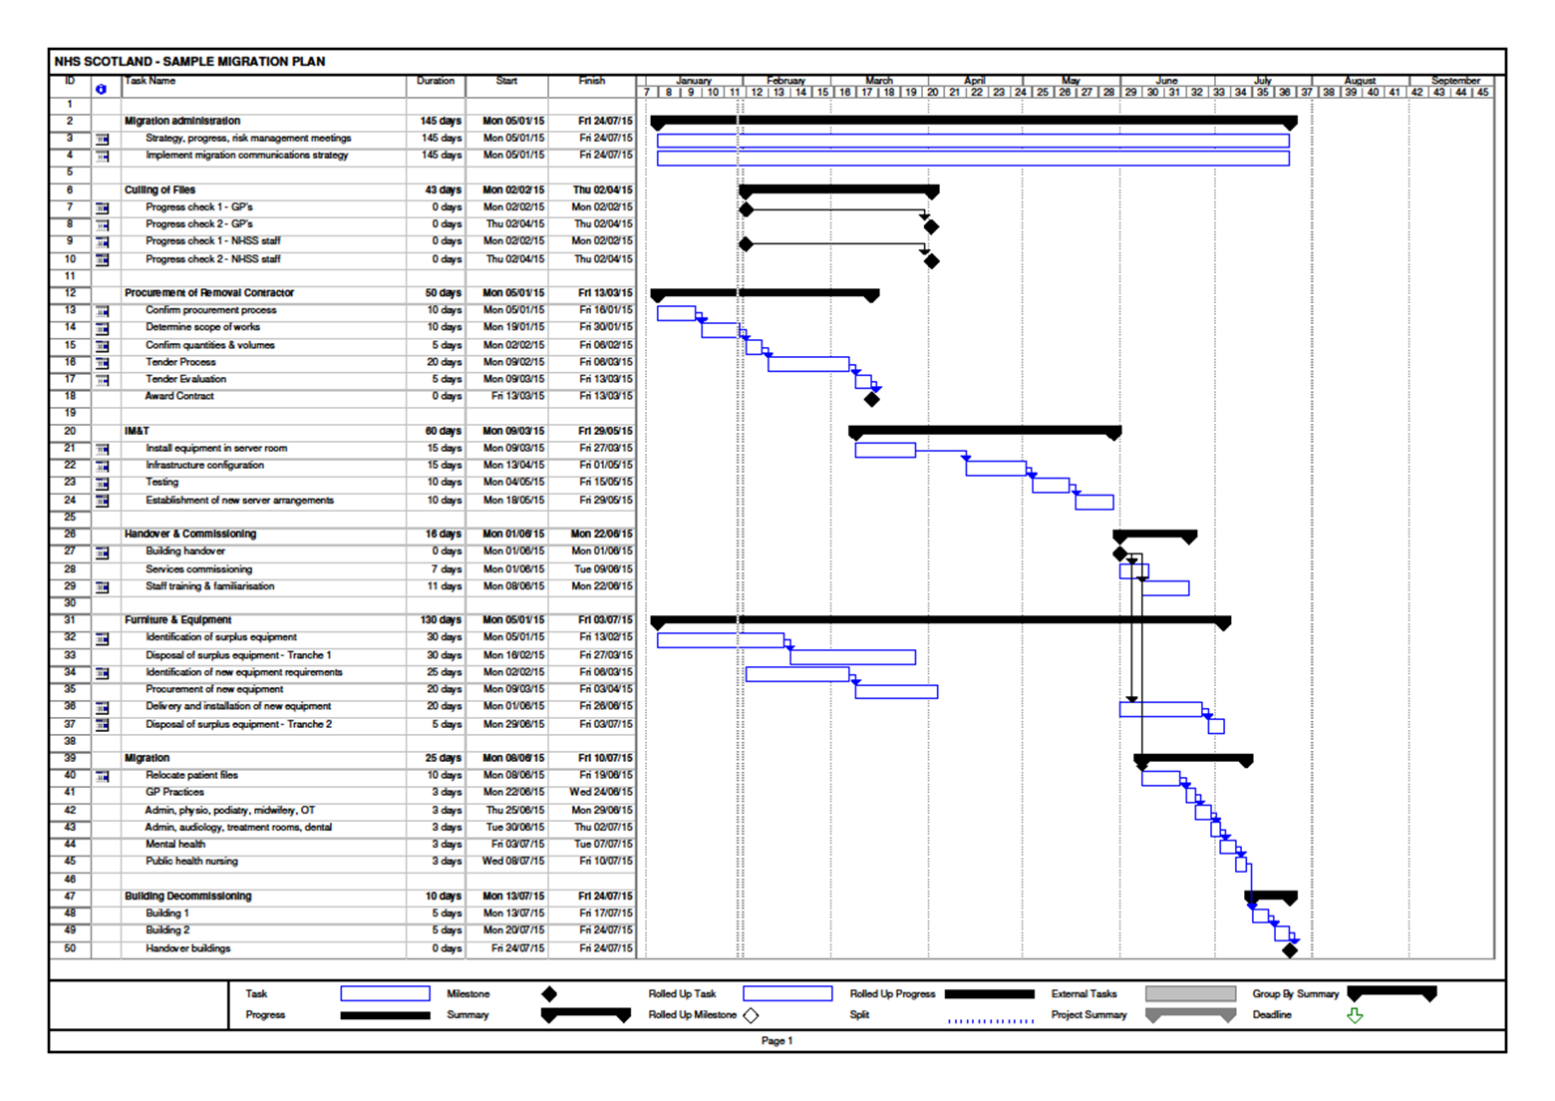

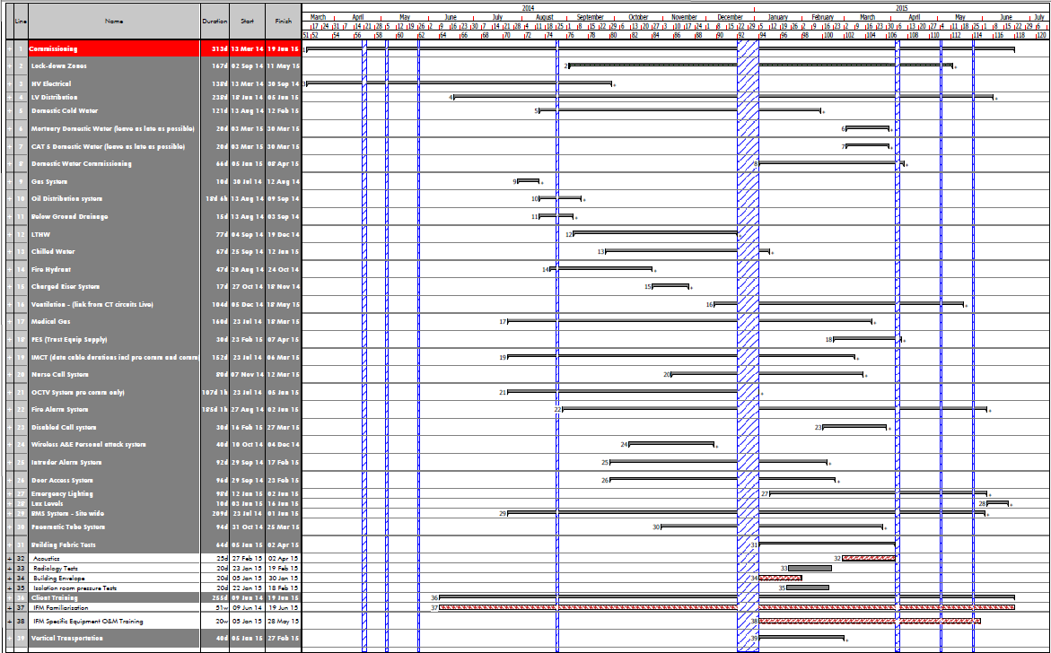

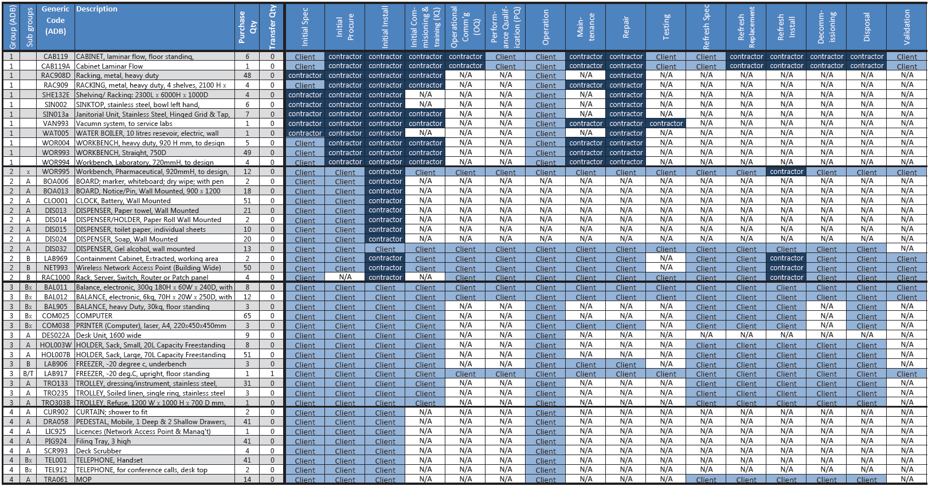

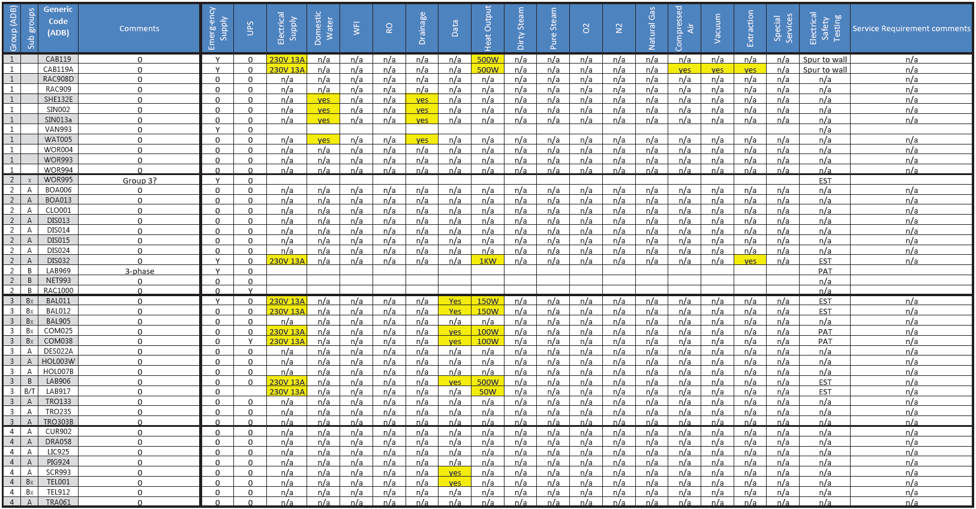

7 – In Use
6 – Handover
5 – Construction
Construction & Commissioning
Project Monitoring
& Evaluation (PME)
4 – Technical
Design
3 – Developed Design
D
Full Business Case (FBC)
Design Development
2 – Concept Design
Outline Business Case (OBC)
Initial Agreement (IA)
1 – Preparation & Brief
Strategic Assessment
0 – Strategic Definition
RIBA
Stages : 2013 2007

B #
A
K
L
F
E
C

Design Brief #
Appraisal
Construction
Post Practical Completion
Production Info.
Technical Design
Concept
# denotes: commissioning briefing elements. These could occur at end of IA stage or, the very start of Outline Business Case stage.
Operational (OC) pre-handover:
- Review mock-ups, design changes etc, by Board/ Client or Contractor
- Arrange security & decant etc
- Commissioning Master Plan (CMP)
- Communications & PR Strategy
- Arrange Visits & Training
- Health Information & Technology
- Final Equipping strategy
- Final SOPs and FM protocols

Operational (OC):
- Migration & Occupations
- Safety, Security & Decants
- IT. Equipping & Logistics
- Decommissioning
- Communications & PR
In Use/ Handover + circa 1yr
- PME report on learning
- Ongoing monitoring and
Reviews (min annually)
Operational
Commissioning Tasks:
Operational Commissioning (OC):
Early OBC
- Appoint Commissioning Manager
- Establish commissioning team & processes
- Establish communications e.g. PD, PM, FM etc
- Review feasibility /options appraisal
Late OBC
- Review Concept Design
- Outline Equipping strategy
- Outline Commissioning Master Plan (CMP)

Operational Commissioning (OC):
- Reviews (min. pre-down selection(s) & mid FBC)
- Standard Operating Procedures (SOPs)
- Develop migration / occupation/ decant strategy
- Develop equipping strategy
- Develop communications & PR strategy
- Develop & coordinate enabling strategy
- Initial safety, security & decant strategy
- Outline communications & PR strategy
- Outline Commissioning Master Plan (CMP)

Commissioning: #
- Establish initial commissioning
brief, processes & protocols
incl, prior projects learning
Technical (TC) pre-handover:
- Final Standards and Derogations
- Report on risks, budgets etc
- Final TADs and Coordination
- Monitor technical commissioning
- Review Snagging / additional works
- Review NDEP and O&M manuals
- Initial Handover report
Technical (TC):
- Final Handover report
- Decommissioning
In Use: (+ circa 1yr)
- PME report on learning
- ongoing O&M (min 3yrs)
e.g. rebalancing vent system
- Ongoing monitoring and
Reviews (e.g. annual NDEP)
Technical Commissioning (TC):
- Review contract terms, Guidance & Standards
- Review Technical Design; record risks etc
- Review Derogations lists; record risks etc
- Agree target NDEP (kW/m²), with HFS support
- Therapeutic & Accessible Design Strategy (TADs)
- Develop Commissioning Brief Requirement (CBR)
- Develop Commissioning risks, resources & budget
Technical Commissioning (TC):
Early OBC
- Establish working groups & technical ‘champions’
- Review Guidance & Standards
- Review feasibility /options appraisal
Late OBC
- Review Concept Design
- Agree key Derogations list
- Outline Commissioning risks, resources & budget

Technical
Commissioning Tasks:

BREEAM (BRE Environmental Assessment Method):
- Assessment – Confirm project target score and extent final credits now evidenced
- Issue interim ‘design’ certificate
BREEAM: (+ circa 1yr)
- Issue ‘final’ certificate
- PME report on learning for future projects and O&M
Healthcare Acquired Infection -HAI SCRIBE:
- Confirm HAI applied in design details & specs.
- Workshops (pre-down selection(s) & late FBC)

Healthcare Acquired Infection -HAI SCRIBE:
- HAI applied in concept and space planning
- Workshops (pre-down selection(s) & late FBC)

BREEAM:
BREEAM (BRE Environmental Assessment Method):
- Pre assessment – Agree project specific target score with HFS support
- Design Stage Assessment
HAI - SCRIBE:

BREEAM pre-handover:
- Assessment – evidence construction score
- Issue NDEP energy cert.

HAI SCRIBE: #
- Establish multi-dis. HAI group
- Brief HAI process & protocols
incl, prior projects learning
HAI SCRIBE pre-handover::
- HAI Construction confirmation & records
HAI SCRIBE: (+ circa 1yr
- PME report on learning for future projects and O&M

CDM: #
- Establish multi-dis. CDM group
- Brief CDM process & protocols
incl, prior projects learning
CDM pre-handover:
- CDM Construction confirmation & records
CDM:

CDM: (+ circa 1yr
- PME report on learning for future projects and O&M
Construction Design Management (CDM)::
- Confirm CDM applied in design details & specs.
- Workshops (pre-down selection(s) & late FBC)

Construction Design Management (CDM):
- CDM applied in concept and space planning
- Workshops : (late OBC, plus OA* ) CDM risk assessments

BIM:
BIM: #
- Data Drop 1 – Initial Brief of operational requirement & Model
Building Information Modelling (BIM):
- Data Drop 2 – Outline Solution Model

Building Information Modelling (BIM):
- Data Drop 3 – Construction Information Model
BIM pre-handover:
- Data Drop 4 – Operational and Maintenance Model
BIM: (+ circa 1yr
- Data Drop 5 – in-use Validation Information Model and ongoing O&M

Soft Landings (SL): 4 & 5
- +1yr independent review
- On-site set-up & monitoring
- Ongoing review (min annual)
Soft Landings:

Soft Landings (SL):#Stage 1
- Initial SL Brief, incl. SL training for all participants
- Establish multi-dis. SL group
Soft Landings (SL): Stage 3
- Pitstop review 4: pre handover review with actual FM staff input, test protocols etc. SL sign-off
Soft Landings (SL): Stage 2
- Pitstop review 1: outline scheme reality check, incl. performance metrics & design/ FM targets
- Pitstop review 2: developed design reality check, incl. report on progress/ risks to achieving above
- Pitstop review 3: tender/ contract award reality check, incl. as above, with key future FM staff input

